ABADIE Maïté
129 rue de brioux
79000 Niort
Tel: 06 83 94 86 04
Driver’s licence. Born 02/11/1988
maite.abadie004@gmail.com

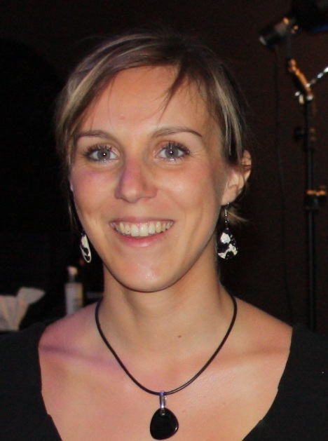
Litterary translator spanish-french

- Strong capacity of adaptation in diferents context social and cultural
- International experience in Latin America
- Bilingal French-Spanish

Professional experience

Sept 2010 -Sept 2013

Fev - Sept 2012

Juillet-Août 2010 et 2011

Déc 2009-Mars 2012

2012-2013
2011-2012

2010-2011
2007-2010

2006-2007

2005-2006

ASTI: voluntary teaching
Staff Managment: recruitment of voluntary teachers qualified and motivated to work in this association
Organisation of culturals activities with a objective educational around a french culture
Teaching all of nivels and instalation of news system to evaluate.

Ricard S.A: hostess Service client
Setting up of comunication’s support and business’s suports
Reception of clients on the spot of consumers
Business’s market research, recruitment of new clients

Banque Populaire Centre-Atlantique
Reception and et recomendation for clients
Creat agreements : opening a bank account, bank transfer national and international Mise en Setting up of comunication’s support and business’s suports.

Collège Aliénor d'Aquitaine/ Lycée Magendie: student participant
Assimilation of interne functioning of school
Organisation educational and help to teaching with tutor’s teacher
Get familiar with the class: preparation by myself for educational’s sequence according to a national program

Schooling

University of Bordeaux 3, Michel de Montaigne

Preparation for a competitive exam to teaching spanish
Master 2 profesional (teaching/translation/research), distinction B.
Pratical training and academic report, Funeral rituals and practices in the maya’s world (classic’s period)
Master 1 profesional (teaching/translation/research), distinction AB. Pratical training and preparation of academic report, collection of informations in territory (Mexico)
Bachelor’s degree in Spanish language and civilization/ Bachelor’s degree to teach French as o foreign language with excellent distinction.

E.S.L Liceo Guadalupe, lycée privée de Zacatecas au Mexique

Baccalaureate general « social-humanistico » (equivalent to High School Diploma), Zacatecas, Mexico.

Lycée Paul Guérin
Baccalaureate general, SES, distinction AB, Lycée Paul Guérin. Niort

Others
Languages: spanish bilingal, english working knowledge, portuguese conversational level/ Mastery of IT tools: Pack Office (C2I nivel 2), Internet
Pastime
Sports activities: Water-polo : since 10 years/ Muay Thai : since one year Hobbys: Bachata: Latin Dance since 3 years.

